`

报告编号：HXT2020-108

巴基斯坦默蒂亚里-拉合尔±660高压直流输电工程
试运行方案

Matiari-Lahore ±660kV HVDC Transmission Project
Trial Operation + CDT Program

China Electric Power Research Institute
2021.06
Version | Date | Modification
... | ... | ...
2.0 | 09 Jun. 2021 | Updated according to TSA requirements
3.0 | 12 Jul. 2021 | Updated according to OE’s comments

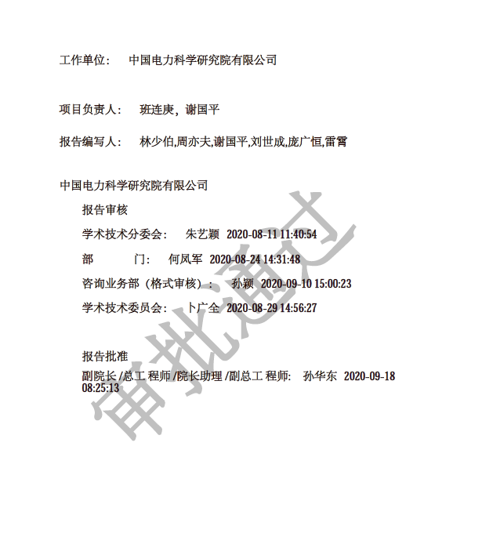
内容摘要
巴基斯坦默蒂亚里-拉合尔高压直流输电工程双极试运行方案内容包括：双极稳定运行，试运行、输送能力验证。

关键词：巴基斯坦默拉直流；168小时试运行；输送能力验证
ABSTRACT
Trial Operation Program for Pakistan Matiari-Lahore ±660kV HVDC Transmission Project includes: Bipole Stable Operation, Trial Operation, Capability Demonstration Test.

KEYWORDS: Matiari-Lahore HVDC Transmission Project, 168-hour Trial Operation, Capability Demonstration Test
Table of Contents
1 Preconditions 3
2 Bipole 168 hours Trial Operation Test 4
2.1 Test Objective 4
2.2 Preconditions 4
2.3 Test Content and Procedure 5
2.3.1 Bipole 168 hours Trial Operation Test 5
4 Safety measures and special points for the tests 7
4.1 For HVDC system 7
4.2 For AC system 8

1 Preconditions
IMPORTANT: The AC voltage at both converter stations including Matiari and Lahore shall be below 550 kV before and during all tests. The frequency at both converter stations shall be in the range 49.5-50.5Hz.
Before starting of Trial Operation the following activities must have been completed:
- Verify that monopole low power tests have been completed.
- Verify that bipole low power tests have been completed.
- Verify that monopole high power tests have been completed.
- Verify that bipole high power tests have been completed.
2 Bipole 168 hours Trial Operation Test

2.1 Test Objective
The test objective is to carry out 168 hours of trial operation including the Capability Demonstration Test.

2.2 Preconditions
（1）All low power tests and high power tests have been completed.
（2）AC system precondition:
1) The 500kV bus voltage of two AC systems is below 550kV.
2）Both sides of AC system are capable to supply the power for the test.
（3）DC system precondition:
Matiari:
[X] Master
[X] SC A Active [ ] SC B Active
[X] PCP A Active [ ] PCP B Active
[X] Normal Pow. Dir. [ ] Reversed Pow. Dir.
[X] With TCOM [ ] Without TCOM
[X] Power Control [ ] Current Control
[X] Joint Control [ ] Separate Control
[X] RPC Auto [ ] RPC Manual
[X] Q control [ ] U control
[X] Norm volt. [ ] Reduced volt.
[X] Ground Return [ ] Metallic Return

LAHORE:
[ ] Master
[X] SC A Active [ ] SC B Active
[X] PCP A Active [ ] PCP B Active
[X] Normal Pow. Dir. [ ] Reversed Pow. Dir.
[X] With TCOM [ ] Without TCOM
[X] Power Control [ ] Current Control
[X] Joint Control [ ] Separate Control
[X] RPC Auto [ ] RPC Manual
[X] Q control [ ] U control
[X] Norm volt. [ ] Reduced volt.
[X] Ground Return [ ] Metallic Return

2.3 Test Content and Procedure

2.3.1 Bipole 168 hours Trial Operation Test
- Verify bipole stable operation at scheduled power from NPCC.
- According to scheduled power from NPCC, bipole will remain in continuous operation for 168 hours trial operation.
- During the 168 hours trial operation, Ramp the power up to Maximum Available Power (MAP) at 100MW/min rate in steps of 400MW, （from the power level when the test is beginning）with an interval of 2 min with stable operation in between each 400MW increase, and keep the bipole in operation for 6 hours at Maximum Available Power.
- Due to the system conditions, the parties agree that the 6-hour Capability Demonstration Test (CDT) can be performed during any 6-hour period of the 168 hours of trial operation even though it had been agreed in Schedule 7 of TSA, CDT shall be performed within the last 72 hours of Trial Operation. If NTDC fails to provide the MAP during the 168 hours Trial Operation, CDT will be performed at any (6) hour period after the Trial Operation.
- Energy Metering data shall be recorded jointly by the Parties at the Receipt Point and at the Delivery Point at the beginning and end of the Capability Demonstration Test. If the amount of the electric energy delivered at the Delivery Point (Lahore Station) by HVDC transmission project during the six (6) hours CDT plus the Allowed Losses during the period equals to (or exceeds) the amount of the electric energy accepted at the Receipt Point by the HVDC project during the six (6) hours, the Tested Transmission Capability (the “Contracted Capacity” ) shall be established.
- After 6 hours Maximum Available Power operation, the bipole power can be adjusted according to scheduled power from NPCC.
- The Maximum Available Power shall not be revised upwards or continue to be revised upward during the Trial Operation up to the Commercial Operation Date.

4 Safety measures and special points for the test

4.1 For HVDC system
- All personnel who take part in the test shall follow all the safety regulations for the electrical works strictly.
- In the station, qualified technicians from the CET or the manufacturer with mobile phone must be appointed to watch the equipment in AC yard, in DC yard and in valve hall separately when a test proceeds. They ought to report immediately to the test leader as they find any abnormality or fault of the equipment.
- No person can enter into the test area without permission.
- All the high voltage area shall be isolated with closed fence and a notice board with ‘HV DANGER!’ should be put on it.
- In the station, an emergent maintenance team with mobile phone shall be ready for any repair or inspection work when needed.
- Only the personnel with the test identity are allowed to enter the test area.
- The qualified operators are only allowed to carry out the operation.
- All the operations shall be done strictly according to the Operation Instructions.
- The temporary test wiring and maintenance of main circuit equipment in site and control & protection cubicles should be proceeded and corresponding safety measures should be carried out by the qualified personnel under the supervision of qualified specialists.
- The test wiring to control or protection cubicles shall be demonstrated and supervised by qualified specialists.

4.2 For AC system
All the regulations and safety measures for the AC system operation have to be followed strictly.

